|  |  |
| --- | --- |
| **Ex. No: 02** | **CREATION OF WEBPAGE WITH ALL TYPES OF CSS** |
| **Date: 28.08.2021** |

**AIM**

To create an HTML page and apply style formatting, using external Cascading Style Sheet.

**ALGORITHM**

Step 1: Start the program.

Step 2: Create an html page.

Step 3: Create an external CSS (Cascading Style Sheet).

Step 4: Link the external style sheet page with the main html page.

Step 5: Load the main page.

Step 6: The style formatting will be applied to the main html page.

Step 7: Stop the program.

**CONCEPTS INVOLVED**

The HyperText Markup Language, or HTML is the standard [markup language](https://en.wikipedia.org/wiki/Markup_language) for documents designed to be displayed in a [web browser](https://en.wikipedia.org/wiki/Web_browser). It can be assisted by technologies such as [Cascading Style Sheets](https://en.wikipedia.org/wiki/Cascading_Style_Sheets) (CSS) and [scripting languages](https://en.wikipedia.org/wiki/Scripting_language) such as [JavaScript](https://en.wikipedia.org/wiki/JavaScript).

[Web browsers](https://en.wikipedia.org/wiki/Web_browser) receive HTML documents from a [web server](https://en.wikipedia.org/wiki/Web_server) or from local storagecc and [render](https://en.wikipedia.org/wiki/Browser_engine) the documents into multimedia web pages. HTML describes the structure of a [web page](https://en.wikipedia.org/wiki/Web_page) [semantically](https://en.wikipedia.org/wiki/Semantic_Web) and originally included cues for the appearance of the document.

[HTML elements](https://en.wikipedia.org/wiki/HTML_element) are the building blocks of HTML pages. With HTML constructs, [images](https://en.wikipedia.org/wiki/HTML_element#Images_and_objects) and other objects such as [interactive forms](https://en.wikipedia.org/wiki/Fieldset) may be embedded into the rendered page. HTML provides a means to create [structured documents](https://en.wikipedia.org/wiki/Structured_document) by denoting structural [semantics](https://en.wikipedia.org/wiki/Semantics) for text such as headings, paragraphs, lists, [links](https://en.wikipedia.org/wiki/Hyperlink), quotes and other items. HTML elements are delineated by *tags*, written using [angle brackets](https://en.wikipedia.org/wiki/Bracket#Angle_brackets). Tags such as <**img** /> and <**input** /> directly introduce content into the page. Other tags such as <**p**> surround and provide information about document text and may include other tags as sub-elements. Browsers do not display the HTML tags, but use them to interpret the content of the page.

HTML can embed programs written in a [scripting language](https://en.wikipedia.org/wiki/Scripting_language) such as [JavaScript](https://en.wikipedia.org/wiki/JavaScript), which affects the behavior and content of web pages. Inclusion of CSS defines the look and layout of content.

Cascading Style Sheets (CSS) is a [style sheet language](https://en.wikipedia.org/wiki/Style_sheet_language) used for describing the [presentation](https://en.wikipedia.org/wiki/Presentation_semantics) of a document written in a [markup language](https://en.wikipedia.org/wiki/Markup_language) such as [HTML](https://en.wikipedia.org/wiki/HTML).[[1]](https://en.wikipedia.org/wiki/CSS#cite_note-1) CSS is a cornerstone technology of the [World Wide Web](https://en.wikipedia.org/wiki/World_Wide_Web), alongside HTML and [JavaScript](https://en.wikipedia.org/wiki/JavaScript).[[2]](https://en.wikipedia.org/wiki/CSS#cite_note-2)

CSS is designed to enable the separation of presentation and content, including [layout](https://en.wikipedia.org/wiki/Page_layout), [colors](https://en.wikipedia.org/wiki/Color), and [fonts](https://en.wikipedia.org/wiki/Typeface).[[3]](https://en.wikipedia.org/wiki/CSS#cite_note-3) This separation can improve content [accessibility](https://en.wikipedia.org/wiki/Accessibility), provide more flexibility and control in the specification of presentation characteristics, enable multiple [web pages](https://en.wikipedia.org/wiki/Web_page) to share formatting by specifying the relevant CSS in a separate .css file which reduces complexity and repetition in the structural content as well as enabling the .css file to be [cached](https://en.wikipedia.org/wiki/Cache_(computing)) to improve the page load speed between the pages that share the file and its formatting.

Separation of formatting and content also makes it feasible to present the same markup page in different styles for different rendering methods, such as on-screen, in print, by voice (via speech-based browser or [screen reader](https://en.wikipedia.org/wiki/Screen_reader)), and on [Braille-based](https://en.wikipedia.org/wiki/Braille_display) tactile devices. CSS also has rules for alternate formatting if the content is accessed on a [mobile device](https://en.wikipedia.org/wiki/Mobile_device).[[4]](https://en.wikipedia.org/wiki/CSS#cite_note-4)

The name *cascading* comes from the specified priority scheme to determine which style rule applies if more than one rule matches a particular element. This cascading priority scheme is predictable.

The CSS specifications are maintained by the [World Wide Web Consortium](https://en.wikipedia.org/wiki/World_Wide_Web_Consortium) (W3C).

**PROGRAM**

**Index.html**

<!DOCTYPE html>

<html lang="en">

<head>

<meta charset="UTF-8">

<meta http-equiv="X-UA-Compatible" content="IE=edge">

<meta name="viewport" content="width=device-width, initial-scale=1.0">

<title>Simple Calculator</title>

<link rel="stylesheet" href="index.css">

</head>

<body>

<div class="bg"></div>

<div class="main">

<form name="form">

<input type="text" class="textview" name="textview">

</form>

<table>

<tr>

<td><input class="button" type="button" value="C" onclick="clean()"></td>

<td><input class="button" type="button" value="Del" onclick="back()"></td>

<td><input class="button" type="button" value="/" onclick="insert('/')"></td>

<td><input class="button" type="button" value="x" onclick="insert('*')"></td>

</tr>

<tr>

<td><input class="button" type="button" value="7" onclick="insert(7)"></td>

<td><input class="button" type="button" value="8" onclick="insert(8)"></td>

<td><input class="button" type="button" value="9" onclick="insert(9)"></td>

<td><input class="button" type="button" value="-" onclick="insert('-')"></td>

</tr>

<tr>

<td><input class="button" type="button" value="4" onclick="insert(4)"></td>

<td><input class="button" type="button" value="5" onclick="insert(5)"></td>

<td><input class="button" type="button" value="6" onclick="insert(6)"></td>

<td><input class="button" type="button" value="+" onclick="insert('+')"></td>

</tr>

<tr>

<td><input class="button" type="button" value="1" onclick="insert(1)"></td>

<td><input class="button" type="button" value="2" onclick="insert(2)"></td>

<td><input class="button" type="button" value="3" onclick="insert(3)"></td>

<td rowspan=5><input style="height: 106px"class="button" type="button" value="=" onclick="equal()"></td>

</tr>

<tr>

<td><input class="button" type="button" value="0" onclick="insert(0)"></td>

<td><input class="button" type="button" value="00" onclick="insert('00')"></td>

<td><input class="button" type="button" value="." onclick="insert('.')"></td>

</tr>

</table> <br>

<p>Designed by N.G. Santhosh Sudhaan</p>

</div>

</body>

</html>

**style.css**

* {

margin: 0;

padding: 0;

}

.bg {

background: linear-gradient(to right, #e91e63, #3151b5);

position: absolute;

top: 0px;

left: 0px;

right: 0px;

bottom: 0px;

}

.main {

position: absolute;

top: 50%;

left: 50%;

transform: translateX(-50%) translateY(-50%);

}

.button {

width: 50px;

height: 50px;

font-size: 25px;

margin: 2px;

cursor: pointer;

/* border-radius: 5px; */

border: none;

color: white;

background-color: #607d8b;

transition-duration: 0.4s;

}

.button:hover {

box-shadow: 0 12px 16px 0 rgba(0,0,0,0.24), 0 17px 50px 0 rgba(0,0,0,0.19);

background: rgb(88, 153, 184);

}

.textview {

width: 208px;

margin: 5px;

font-size: 25px;

padding: 5px;

border: none;

/* border-radius: 5px; */

background-color: #ffffff;

}

.name {

padding: 20px;

bottom: 0;

right: 0;

text-align: right;

position: absolute;

color:silver;

font-family: Berlin Sans FB;

font-style: oblique;

font-size:large;

}

**OUTPUT**

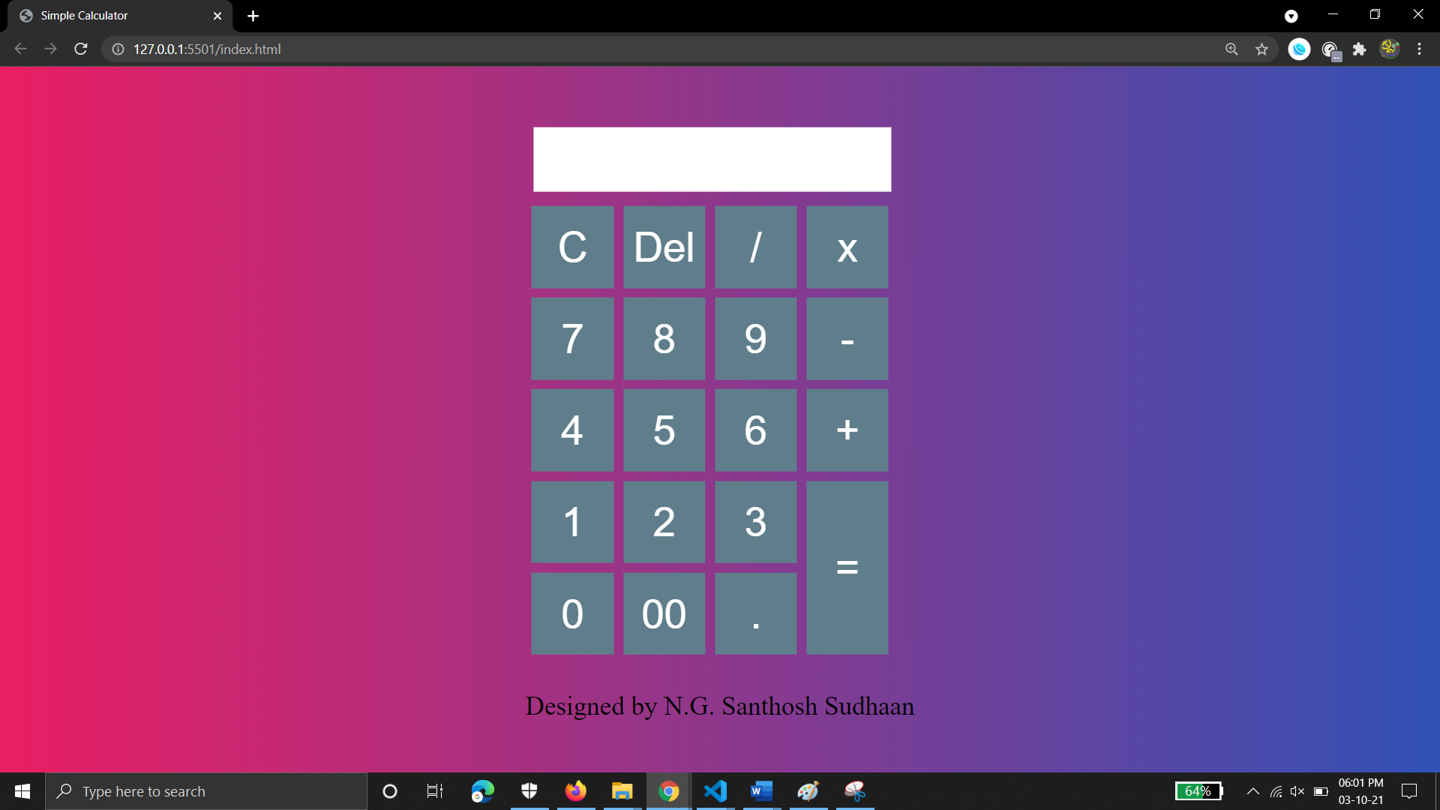

**Result:**

I have created an HTML page and applied style formatting, using Cascading Style Sheet and output was successfully verified.